

St Michelle – French Pattern

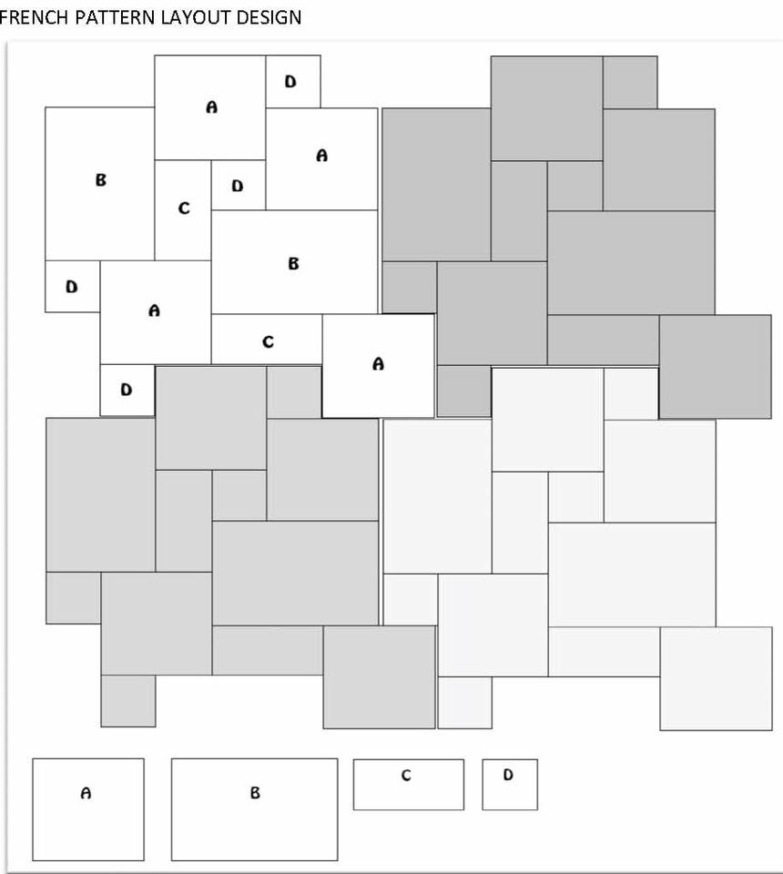

1400mm

2800mm

1400mm

|  |  |  |  |
| --- | --- | --- | --- |
| Code | Paver Size | Quantity Per Panel | Total Required |
| A | 400x400 | 4 |  |
| B | 600x400 | 2 |  |
| C | 200x400 | 2 |  |
| D | 200x200 | 4 |  |

St Michelle in Bondi Sand

